**Family Media**

[A simple social media platform]

Developed By: S M Faisal

**About:** *Family media* is a web application where anyone can post their thoughts, like-comment to others post, make friends, chat with other users, building profile. Also there is a feature to get notifications generated from the system that can help you to remind things like some one commented on your post or sent you friend request or like your post or any of your friends birthday. Also you can block any user so that he/she will not text you or not able to see your profile anyhow.

**Features:** Here I made as much feature as I can. All features are described below-

1. **Post:** You can post image or text. A post will compose of 4 part- Post Title, Post Privacy, Post Data and Attached Image.
2. **Post Title:** Post title must be within 100 character.
3. **Post Privacy:** Post privacy are of 3 types- Public, Friend and Only Me.
   1. **Public:** This post can be visible to any user of the system.
   2. **Friend:** This type of post will be visible only to the users friends.
   3. **Only Me:** This type of post will only visible to the user who posted the post.
4. **Post Body:** Post data is the text, the body of the post.
5. **Attached Image:** This part is optional, if user want they can attach image to their post. (Under construction, not implemented yet)

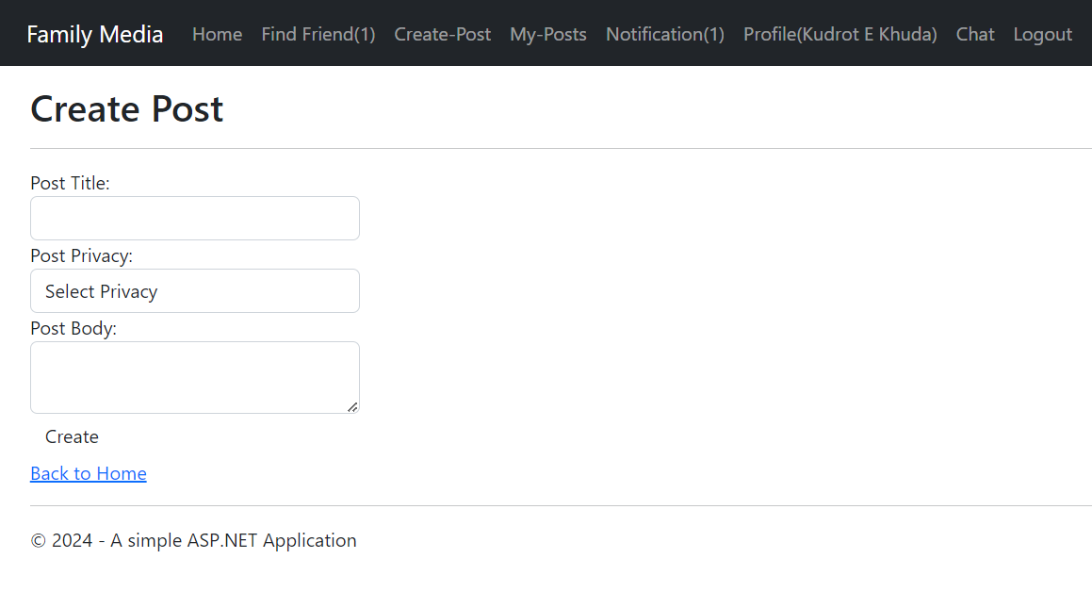

1. **Home:** There are two types of home, one for visitors and one for users of the system.
2. **Visitors Home:** This is a non-static page where user can get a overview of the website.
3. **Users Home:** This is home page of registered users. After successfully login user can visit this page from nav-bar. Here user will find other users post who are maybe his/her friend that are public or his/her friends post where posts privacy can be *Friend* or *Public*. From home which posts he already liked that message will be included with each post with the like and comment count(comment count is under construction). Also at the top of the home page user will see many type of messages generated from the system that can improve user experience.

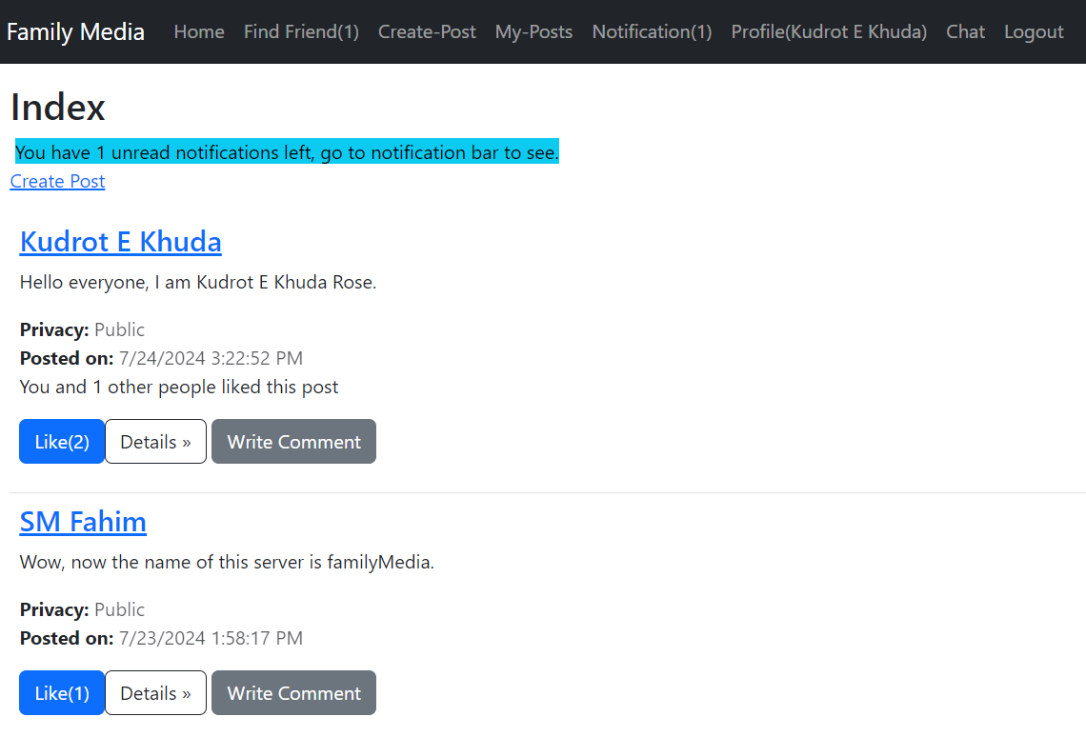

1. **Like:** User can give like to those posts where post privacy is public. If post privacy is friend then user will not even able to see that post nor like. If a posts privacy is *Friend* and that posts owner is his/her friend then he can see that post and also be able to like that post.